CURRICULUM VITAE



ARUNIMA BANIK, B.Sc Nursing

# CAREER OBJECTIVE:

To gain exposure to new challenges in clinical field and to contribute wholly to the welfare of the hospital through my specialized skills.

Email : [arunima19banik@gmail.com](mailto:arunima19banik@gmail.com)

Phone no 8637896392

Date of Birth : 29/1/1995

Age : 27

Sex : Female

Blood group : A+ve

Height : 5ft 3inch

Father’s Name : Mr. AMARESH CHANDRA BANIK

Mother’s Name : Mrs. RINA BANIK

Religion and Caste : HINDU

Marital Status : SINGLE Nationality : INDIAN

Permanent Address : VILL-BLOCK PARA, PO & PS-ISLAMPUR

DIST-UTTER DINAJ PUR STATE- WEST BENGAL PIN CODE -733202

# Present Address : 12(OLD 12C) ARABINDO SARANI, AMAR APPARTMENT, AIRPORT GATE NO -1

DIST-North 24 parganas, STATE- WEST BENGAL PIN CODE -700099



PROFESSIONAL

SKILLS

hospital acquired infection.

patient

the

of

Identification

Care planning & decision making Active and passive surveillance

Audit of care bundles.

•

•

•

•

and

records

of

Management

reports

Active participation Time management

Procedure development

•

•

•

•

* Direct patient care
* Proficient documentation
* Inter-personal skills
* Confidential discreet
* Vital monitoring
* Emergency care
* Dispense medication
* Patient education and counseling

EQUIPMENT HANDLING



SKILLS

* Catheterization
* Pulse oxymeter
* Ambu bag with mask
* Iv infusion
* Oxygen analyzer
* Suction apparatus
* Syringe pump
* Nebulizer
* Infusion pump
* Glucometer
* Oxygen cylinder
* ABG analysis

# LANGUAGES KNOWN:



1. ENGLISH : - Read, write and speak
2. HINDI : - Read, write and speak
3. BENGALI : - Read, write and speak
4. ODIA : - Speak,

PROFESSIONAL EXPERIENCE

* Fresher, worked at PEDIATRIC WARD, PRADUMAN BAL MEMORIAL HOSPITAL , KIMS, BHUBNESWAR , ODISAHA during Internship period.
* 3year experience(05/05/2019-till date ) as a Infection control nurse at Medica Superspecialty Hospital, kolkata ..

MY STRENGHTS

* + Punctuality
  + Patience
  + Quick learner
  + Hard working
  + Receptive to new idea and learning
  + Good Communication skills
  + Self-confidence
  + Proficiency in computer



ACADEMIC



QUALIFICATION:

|  |  |  |  |
| --- | --- | --- | --- |
| Qualification | Institution | % of marks | Year |
| 10TH | ISLAMPUR GIRLS HIGH SCHOOL | 74.4 | 2011 |
| 10+2 | ISLAMPUR GIRLS HIGH SCHOOL | 64.4 | 2013 |

PROFESSIONAL

QUALIFICATION:



|  |  |  |  |  |
| --- | --- | --- | --- | --- |
| QUALIFICATION | COLLEGE | UNIVERSITY | % OF MARKS | YEAR |
| B.SC NURSING 1st  year | KALINGA INSTITUTE OF NURSING SCIENCES | KIIT(deemed to be UNIVERSITY), BHUBANESWAR, ODISHA | 63.4% | 2014 |
| B.SC NURSING  2nd year | KALINGA INSTITUTE OF NURSING SCIENCES | KIIT(deemed to be UNIVERSITY), BHUBANESWAR, ODISHA | 68.2% | 2015 |
| B.SC NURSING 3rd  year | KALINGA INSTITUTE OF NURSING SCIENCES | KIIT UNIVERSITY, BHUBANESWAR, ODISHA | 69.1% | 2016 |
| B.SC NURSING 4th  year | KALINGA INSTITUTE OF NURSING SCIENCES | KIIT UNIVERSITY, BHUBANESWAR, ODISHA | 65% | 2017 |

:



CERTIFICATE



COURSE

1. Infection control nurse program, Aarohan health care, on 11november 2020



CONFERENCE ATTENDED:

* 1. Workshop on “BREAST FEDING: A KEY TO SUSTAINABLE DEVELOPMENT” at KALINGA INSTITUTE OF NURSING SCIENCES, on date 5/8/2016 .
  2.  MIDWIFARY PRACTICE” Society of midwives, 3rd state level conference, India-Odisha chapter, on date from 17th December-2016.



“REVITALIZING

* 1. State level seminar on FOR MOT~~HE~~RS AND THEIR NEWBORNS-



“CARING

MIDWIVES ROLE” at DRIEMS school and college of nursing ,tangri,cuttack on date 31st march 2017.



EXTRACURRICULAM



1. Participated in FLASH MOB in WORLD AIDS DAY-2015.
2. “RIGHT TO HEALTH” world aids day, panel discussion at KALINGA INSTITUTE OF NURSING SCIENCES, on date from 1st December -2017.
3. Roll play in Workshop on BREAST FEDING: A KEY TO SUSTAINABLE DEVELOPMENT at KALINGA INSTITUTE OF NURSING SCIENCES, on date 5/8/2017.
4. Head of disciplinary committee at KIMS fest on December 2017.

HOBBIES

* Dancing
* Swimming DECLARATION

I hereby declare that the above said information are true and correct to the best of my knowledge and belief.

Signature

Place: Bhubaneswar Date: .08.2018

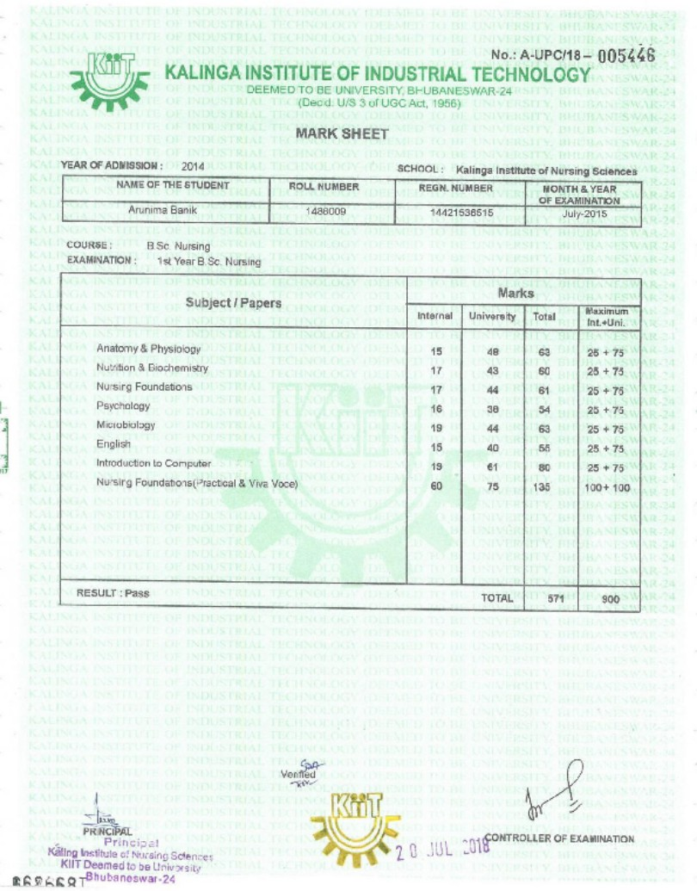

X

